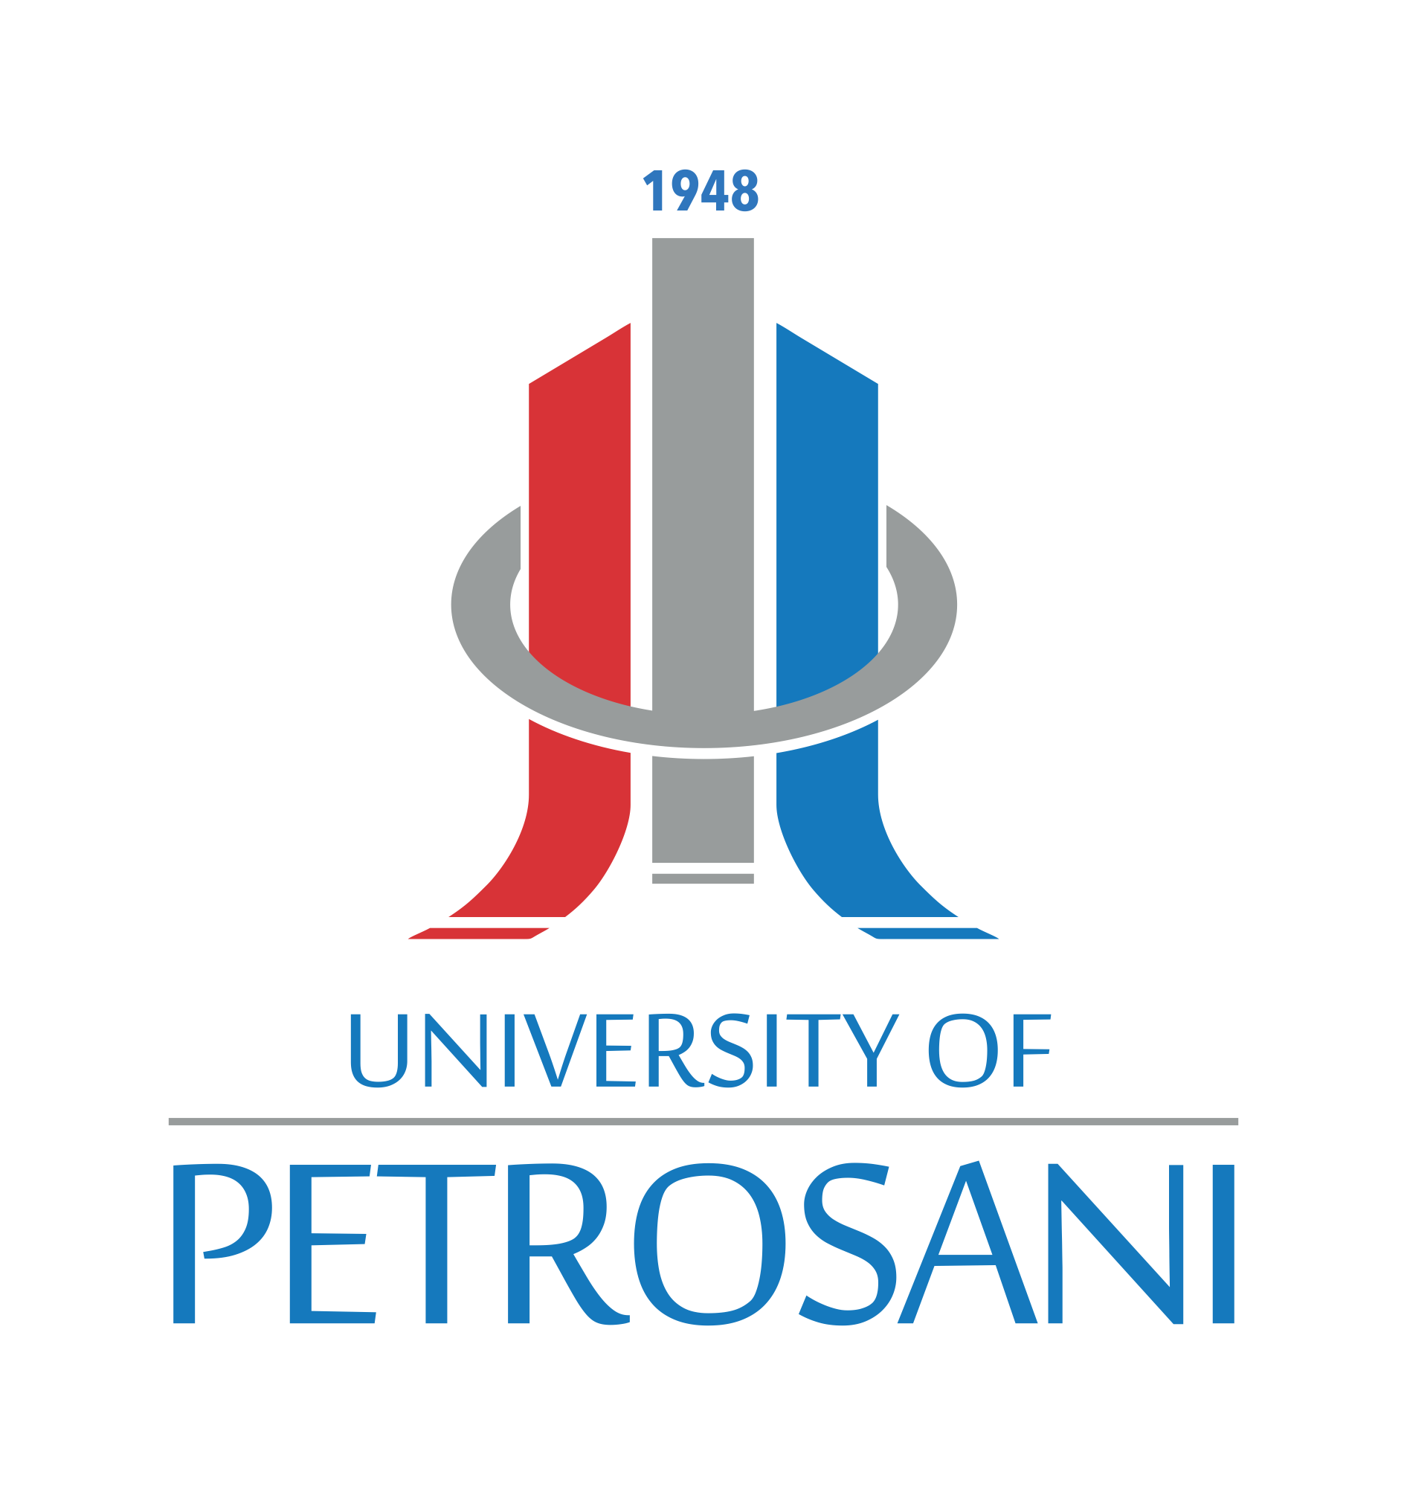 |  |  | 8th INTERNATIONAL MULTIDISCIPLINARY SYMPOSIUM  „UNIVERSITARIA SIMPRO 2018”  Petroșani, Romania, 11-13 October 2018
SYMPOSIUM PARTICIPATION REGISTRATION FORM
Please fill out the registration form and send it to simpro@upet.ro at the latest by 01 September , 2018.

PERSONAL DETAILS
Please carefully complete your personal details which will allow for continuous communication, and at the same time will be used in publication of the list of participants. Please use the printed letters for filling the Form.
PARTICIPANT DETAILS
Academic title:
First name: |  |  |  | Last name:
Institution:
Department:
Adress:
Postal code: |  |  |  |  | City:
Country: |  |  |  |  | Telephone number:
Fax: |  |  |  |  | e-mail:
PAPER DETAILS
Title of paper:
Topic (select one from 1-11, see CFP):
Fellow authors:
Presenting author¹
ACCOMPANYING PERSON(S)
First name: |  |  |  |  | Last name:
First name: |  |  |  |  | Last name:
1- IMPORTANT: If paper is sent “only for publication”, please mention that in this row

Upon receipt of your registration form, you will be contacted by the Section secretary and a written notification will be sent to you by e-mail about acceptation and payment info. All further interactions will be pursued with the Section secretary.

Please keep in mind the deadlines:
01 July 2018 –abstract submission
15 July 2018 – notification of abstract acceptance
01 September 2018 – full paper submission
08 September 2018 – notification of paper acceptance
15 September 2018 – conference fee payment
1st October 2018 – final program

